PROGRAMMING IN JAVA
ASSIGNMENT 2 – CO2
Name: J.Subhaashree Register Number: 192424008
Course: B.Tech Artificial Intelligence and Data Science

1. Aim
To implement and evaluate Java strings, collections, hash-based equality, maps, generics, comparators and priority queues, then diagnose and validate a redesigned solution using measured execution-time evidence.

2. Execution environment and evidence
The submitted executed Google Colab notebook installed OpenJDK 17, compiled Assignment2.java and ran Q1–Q7. The values below are taken from the recorded output tables and console output in that notebook. Timings are specific to that Colab session and should not be treated as universal performance guarantees.
The notebook displayed all Q1, Q4, Q6 and Q7 measurement rows. For Q2, the notebook displayed only q2.head(15), so the CSV included in this package is explicitly a preview of those 15 displayed rows. Download the full Q2 CSV from the original Colab runtime before final submission.

3. Q1 — String, StringBuilder and StringBuffer
Recorded best-of-three timings (nanoseconds):
Workload | String + | StringBuilder | StringBuffer
1x10 | 40,306 | 16,203 | 18,659
1000x50 | 19,896,378 | 10,277,660 | 12,653,661
3000x100 | 44,643,465 | 20,972,140 | 24,562,781
In all three recorded workloads, StringBuilder had the lowest measured time. String is immutable, so repeated concatenation creates intermediate strings and repeatedly copies accumulated content. StringBuilder mutates an internal buffer. StringBuffer is synchronized and may add overhead. Recommendation: use a local StringBuilder for each ticket; use a properly synchronized logging facility or a lock for a shared multithreaded log.
Complexity: repeated concatenation can copy O(L²) total characters for n similarly sized fields; StringBuilder construction is amortized O(L), where L is the final output length. StringJoiner/String.join are suitable when values are already available as strings.

4. Q2 — ArrayList, LinkedList and ArrayDeque
The notebook tested add-at-end, add-at-front, middle insert/remove, indexed access and iteration at playlist sizes 1,000, 5,000 and 10,000. Its display statement used head(15), so only the first 15 records are visible in the uploaded notebook. The included preview CSV preserves those rows; it is not represented as the complete benchmark.
Complexity summary: ArrayList add-at-end is amortized O(1), indexed get is O(1), and front/middle insertion is O(n) due to shifting. LinkedList insertion/removal is O(1) once the node is reached, but indexed access and locating a middle position are O(n). ArrayDeque addFirst/addLast/removeFirst are amortized O(1), but it does not support indexed access. ArrayList is suitable for random access and append-heavy playlists; ArrayDeque is a better fit for an Up Next deque.

5. Q3 — hashCode() and equals()
Recorded output: the deliberately broken class retained two objects with the same registration number (observed set size 2). The corrected Student class, whose hashCode() is derived from regNo consistently with equals(), produced: Unique students: 2. HashSet uses hashCode() to locate a bucket and equals() to compare candidates within that bucket. Fields used in equality/hash calculations should not be mutated while an object is stored in a hash collection.
Alternative: HashMap<String, Student> keyed by registration number provides average O(1) lookup/insertion; TreeSet with a registration-number comparator provides O(log n). Both require O(n) storage for n unique students.

6. Q4 — HashMap, TreeMap and LinkedHashMap
Recorded lookup and report timings (nanoseconds):
Size | Map | 100k lookups | Code report | Iteration report
1,000 | HashMap | 16,287,205 | 3,864,748 | 1,171,406
1,000 | TreeMap | 32,890,351 | 1,073,030 | 831,894
1,000 | LinkedHashMap | 5,737,213 | 549,496 | 652,558
5,000 | HashMap | 11,179,765 | 6,438,083 | 1,305,380
5,000 | TreeMap | 32,095,100 | 1,413,207 | 2,373,270
5,000 | LinkedHashMap | 8,298,110 | 729,181 | 1,083,756
10,000 | HashMap | 8,865,000 | 10,154,766 | 4,740,020
10,000 | TreeMap | 36,939,531 | 3,185,882 | 5,134,522
10,000 | LinkedHashMap | 10,765,897 | 1,498,786 | 1,936,141
HashMap offers average O(1) put/get but no ordering guarantee. TreeMap offers O(log n) put/get and naturally keeps keys sorted. LinkedHashMap offers average O(1) put/get and preserves insertion order. Therefore TreeMap naturally supports the code-order report, while LinkedHashMap naturally supports the order-added report. Sorting a HashMap's keys for a report requires O(n log n) additional work.

7. Q5 — Generic leaderboard
Recorded output: [Eagles(9,6), Bisons(9,4), Panthers(9,4), Cobras(6,1)]. The comparator ranks points descending, goal difference descending, and team name ascending. Bisons is above Panthers because the first two fields tie and 'Bisons' precedes 'Panthers' alphabetically. A generic Leaderboard<T> accepts Comparator<? super T> and sorts a copy so its original item list is not modified. One comparator chain performs one O(n log n) sort and can be reused for other entity types.

8. Q6 — Hospital emergency triage
Recorded treatment order: Meena(S1) Kumar(S1) Lata(S2) Ravi(S3) John(S3) Asha(S5). The priority queue comparator sorts lower severity number first, then earlier arrival counter. PriorityQueue add and poll are O(log n), peek is O(1), and storage is O(n). Printing the queue directly does not promise sorted order; poll a copy to display treatment order. Starvation of minor cases can be reduced with a waiting-time aging policy.
Patients | Add all (ns) | Remove all (ns)
1,000 | 1,598,531 | 3,187,201
5,000 | 1,165,776 | 5,868,066
10,000 | 2,631,866 | 9,905,697
A volume of 5,000 patients per day is modest for O(log n) queue operations, but a real hospital deployment also needs concurrency controls, persistence, monitoring and clinically approved triage rules.

9. Q7 — Diagnose, redesign and validate
Diagnosis: inserting at index 0 in ArrayList shifts existing references, so repeated front insertions accumulate O(n²) movement. Redesign objective: reduce front-insertion work by using ArrayDeque.addFirst(), which is amortized O(1).
Insertions | ArrayList (ns) | ArrayDeque (ns)
1,000 | 240,772 | 168,337
5,000 | 1,946,416 | 788,667
10,000 | 7,483,076 | 1,472,004
20,000 | 28,916,867 | 3,428,460
The recorded run supports the prediction: ArrayDeque was faster at all four tested sizes. At 20,000 insertions, ArrayList took 28,986,867 ns while ArrayDeque took 3,428,460 ns (use exact values from the table/CSV above). The trade-off is that ArrayDeque has no indexed get; ArrayList remains preferable when random access is important.

10. Conclusion
The experiments demonstrate that collection choice should follow the dominant workload. StringBuilder is appropriate for local text construction, ArrayList for indexed playlists, ArrayDeque for double-ended queues, correct hashCode/equals implementations for HashSet, TreeMap and LinkedHashMap for ordered reports, Comparator-based generic ranking for reusable ordering, and PriorityQueue for severity-based service. The Q7 redesign reduced the measured cost of repeated front insertion in this Colab run.

11. Submission checklist
- Java source code included
- Q1–Q7 output evidence panels included (reconstructed from notebook output)
- CSV benchmark data included; Q2 CSV is only a 15-row preview and must be replaced with full Colab CSV
- Performance graphs included
- Assignment report included
- GitHub repository must be created and pushed by the student; credentials/repository access were not provided
Student verification: I have executed and reviewed the code and measurements and can explain the design decisions and results.
Signature: __________________________ Date: __________________

12. Performance graphs
Q1 1000x50
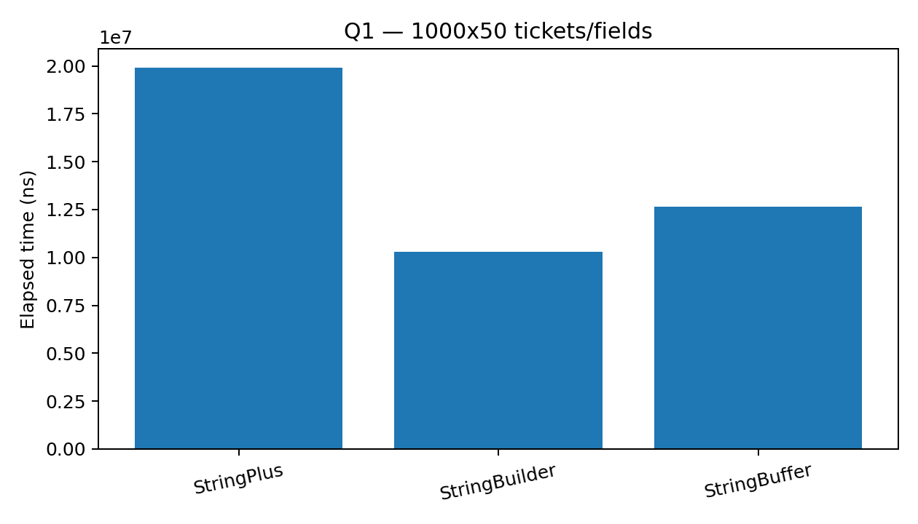
Q1 1x10
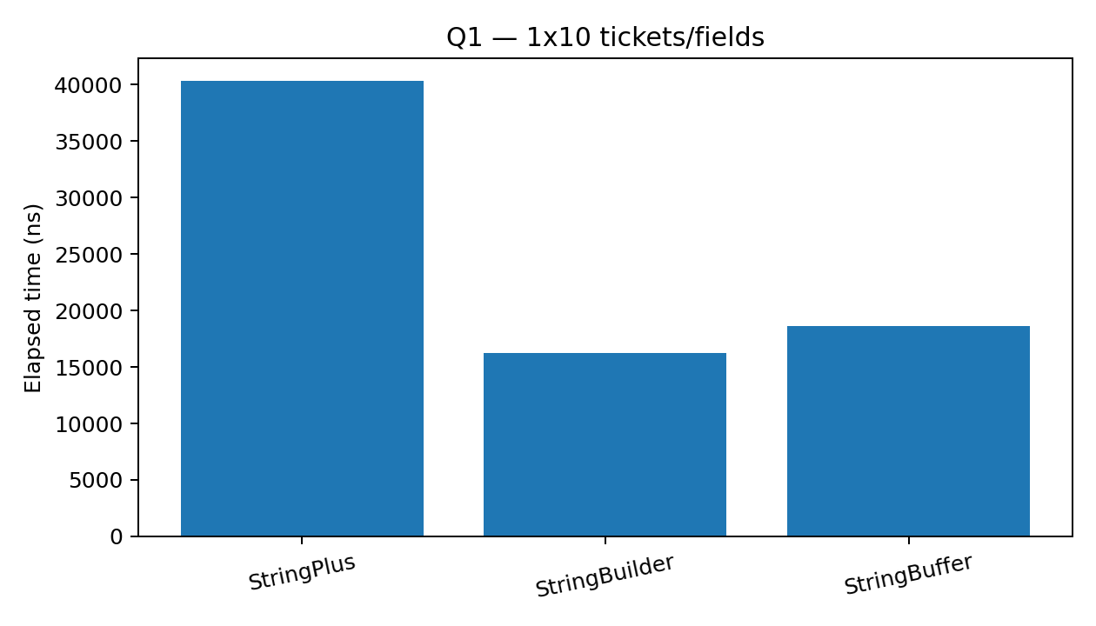
Q1 3000x100
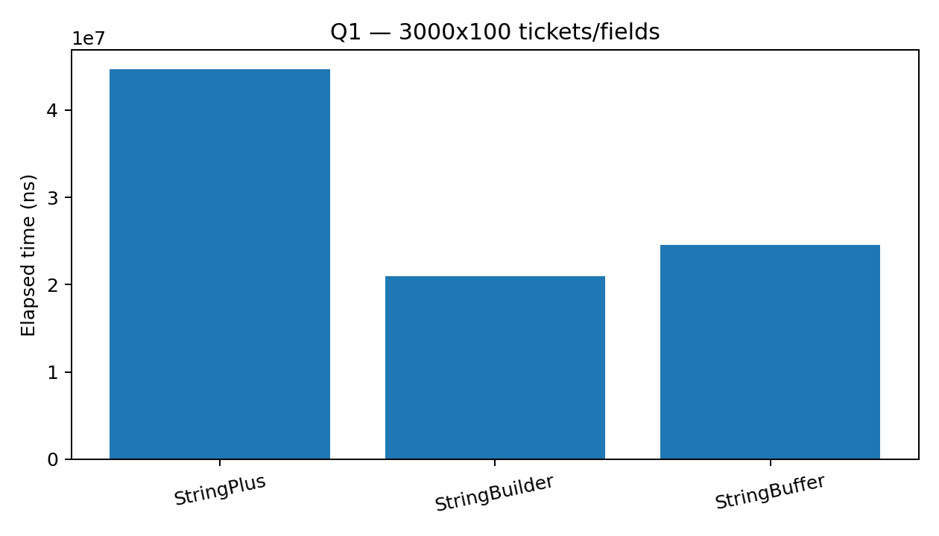
Q2 addEnd
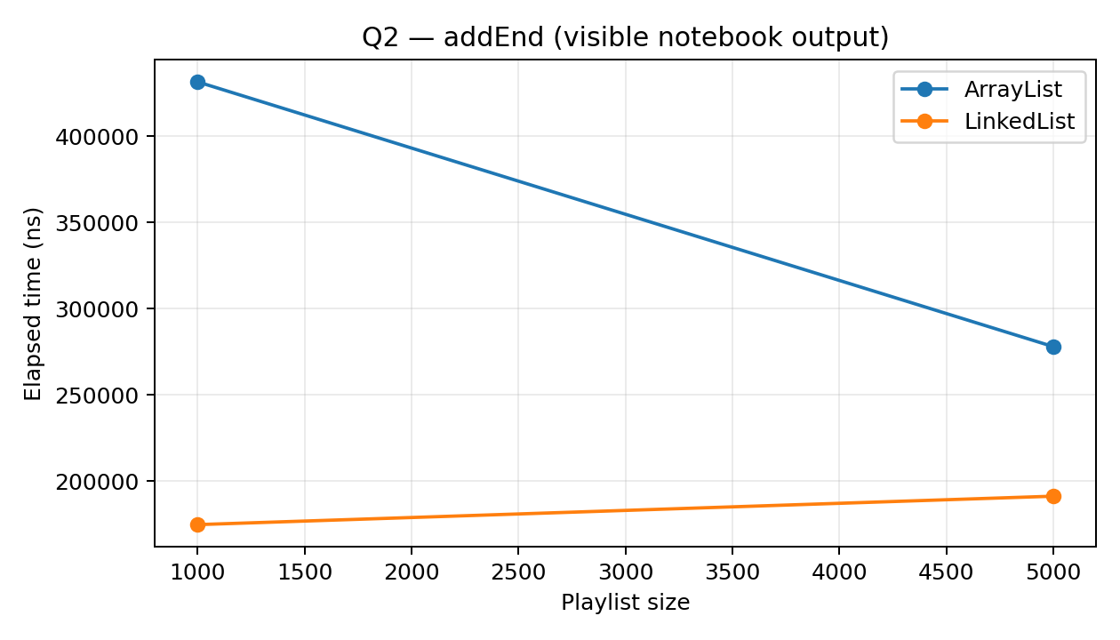
Q2 addFront
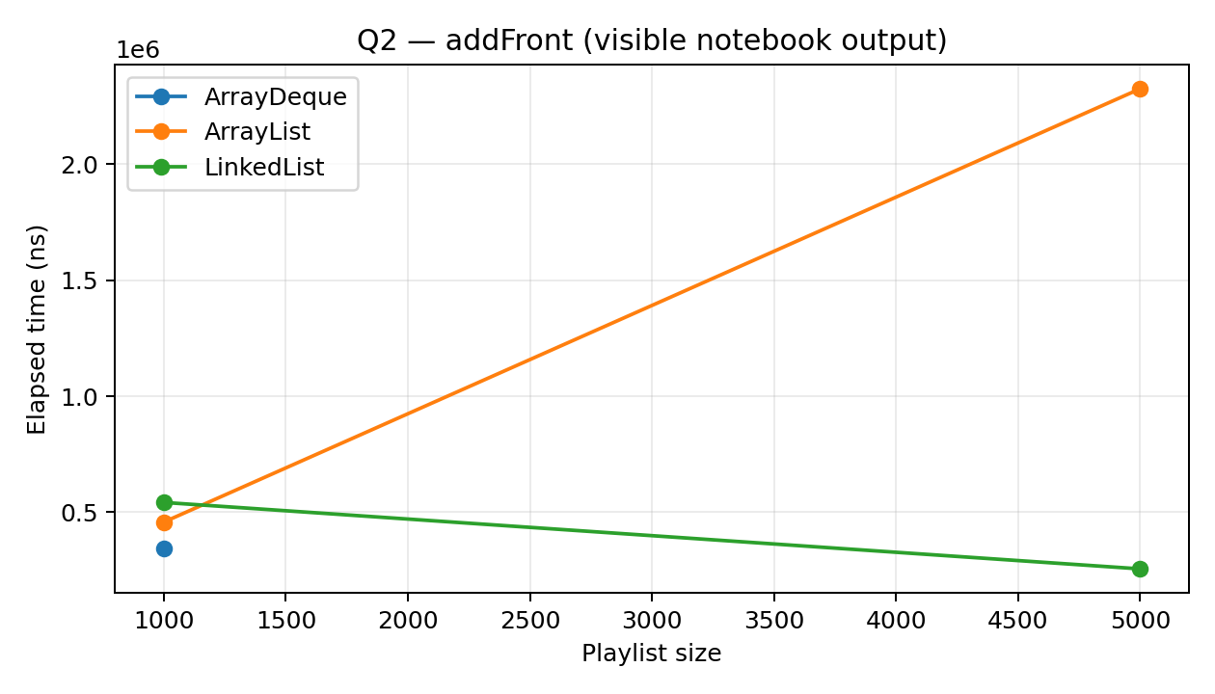
Q2 getK
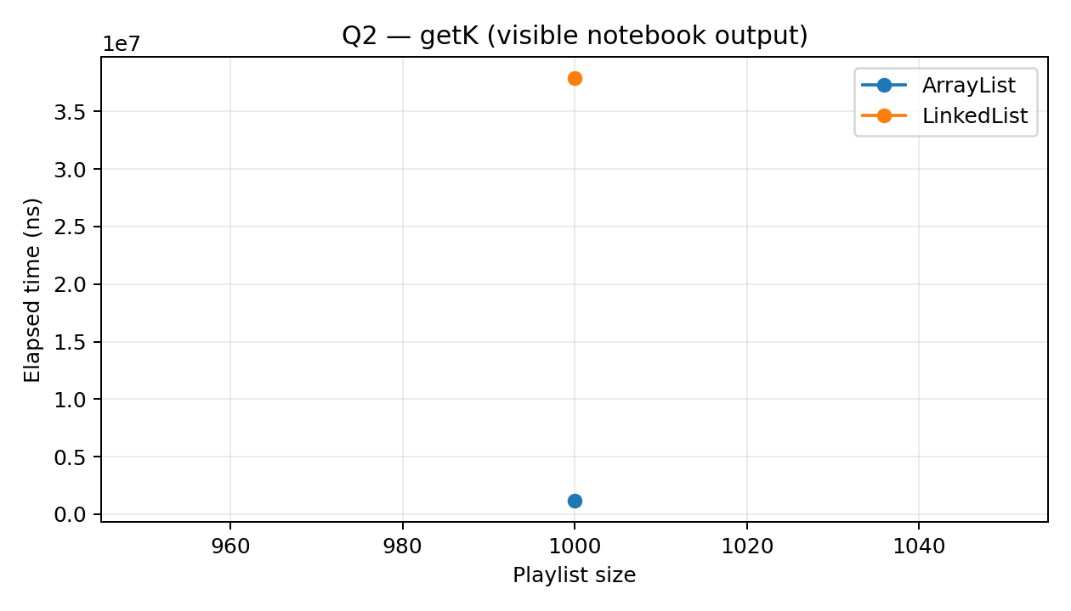
Q2 insertRemoveMiddle
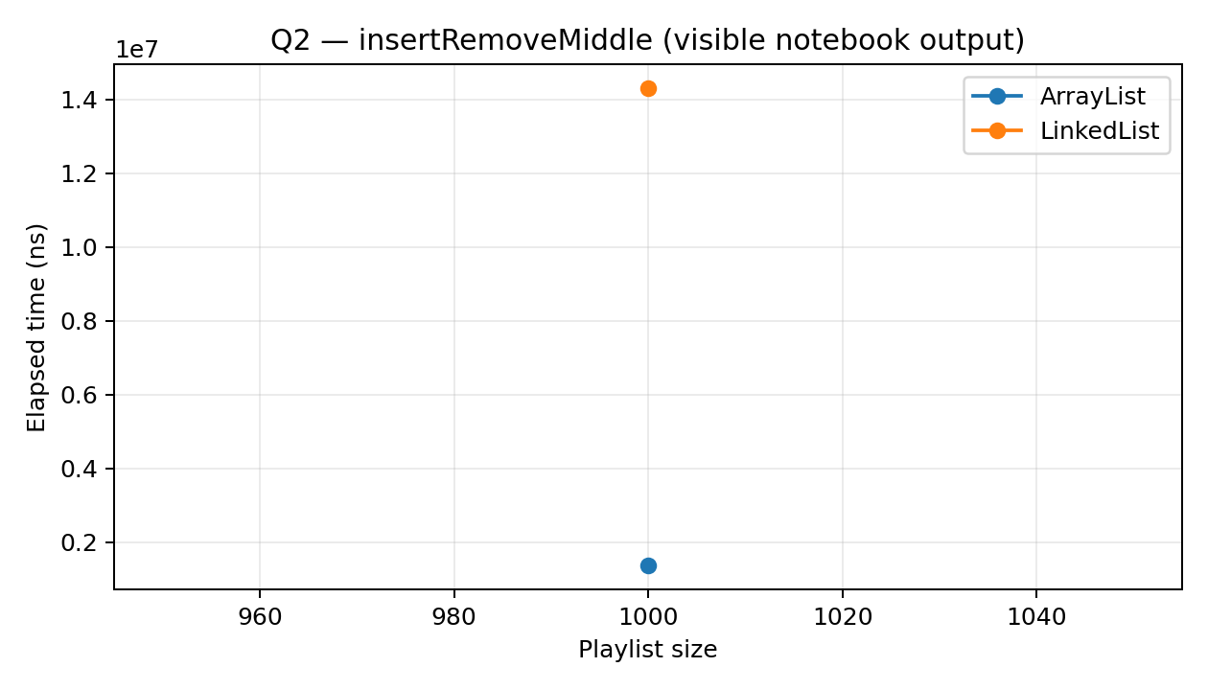
Q2 iterate
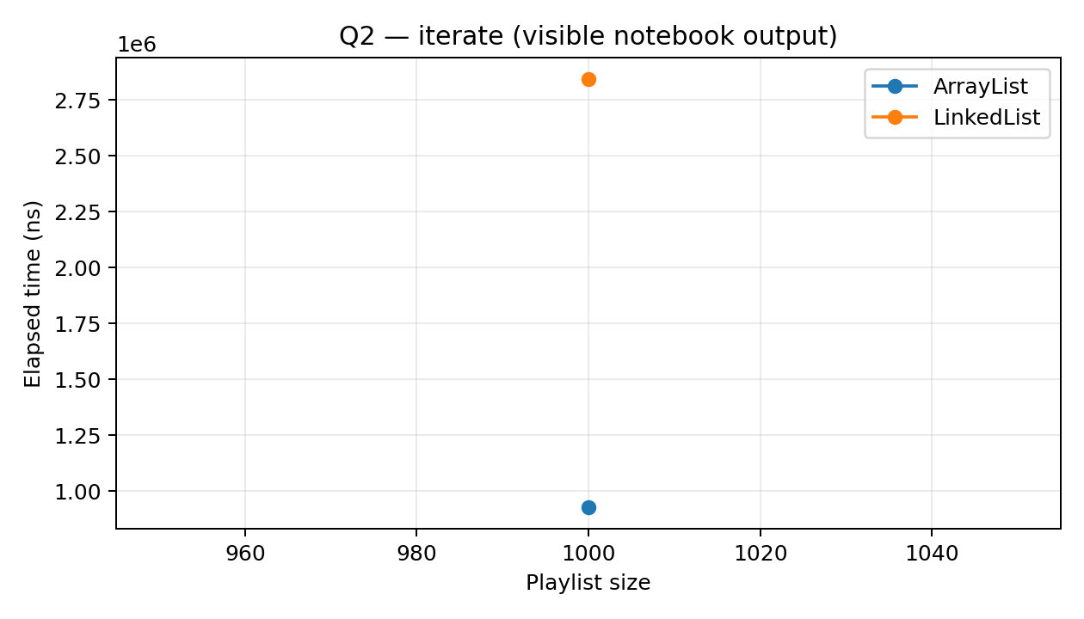
Q4 code report
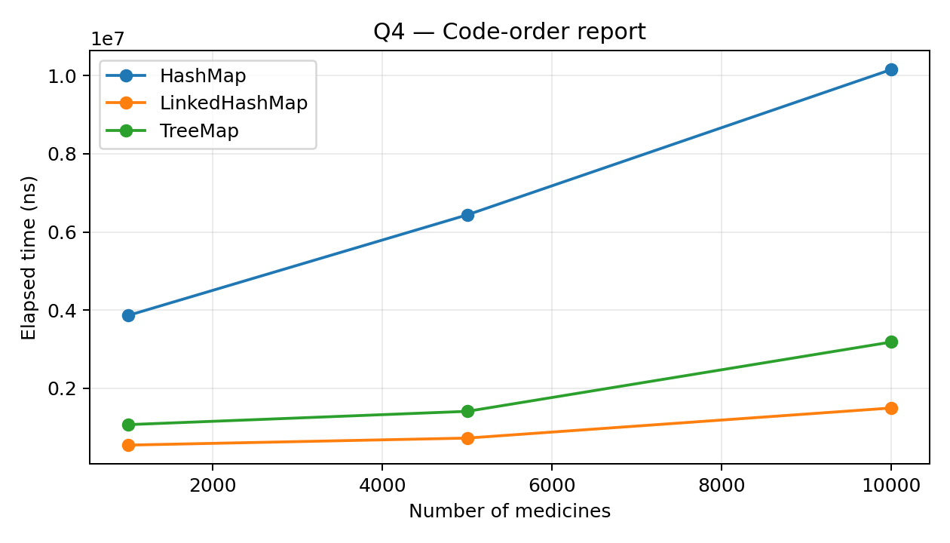
Q4 iteration
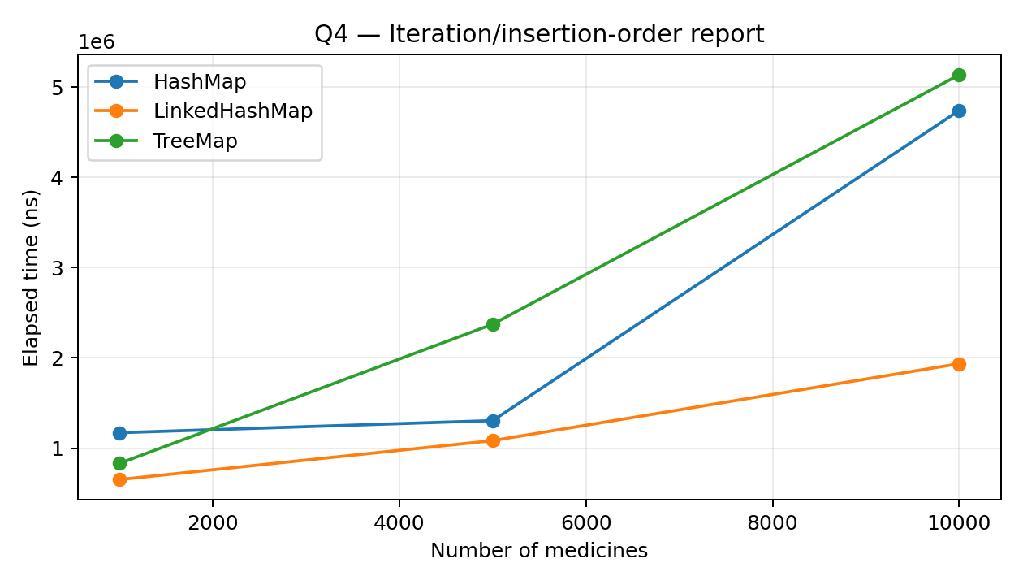
Q4 lookup
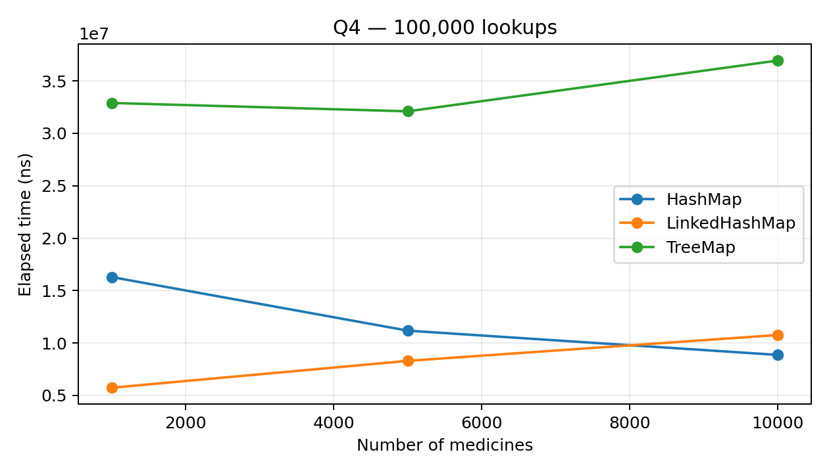
Q6 priority queue
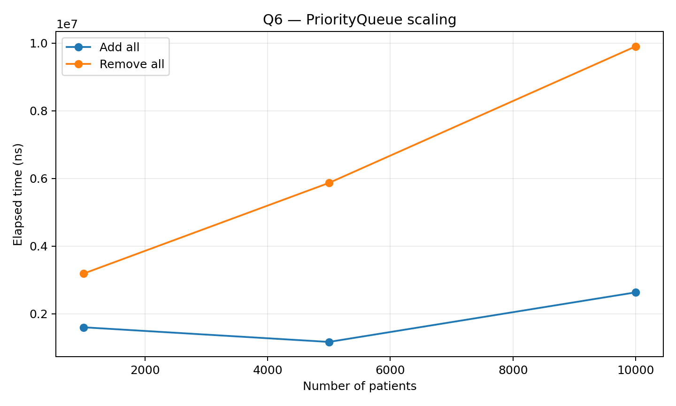
Q7 redesign


